Program Catalogue | 2024-2025 | دليل البرنامج الدراسي

University of Diyala  جامعة ديالى | 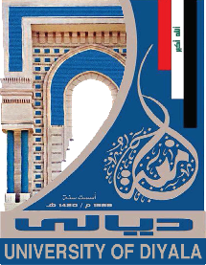

First Cycle – Bachelor’s Degree (B.Sc.) – Economy
بكالوريوس – اقتصاد

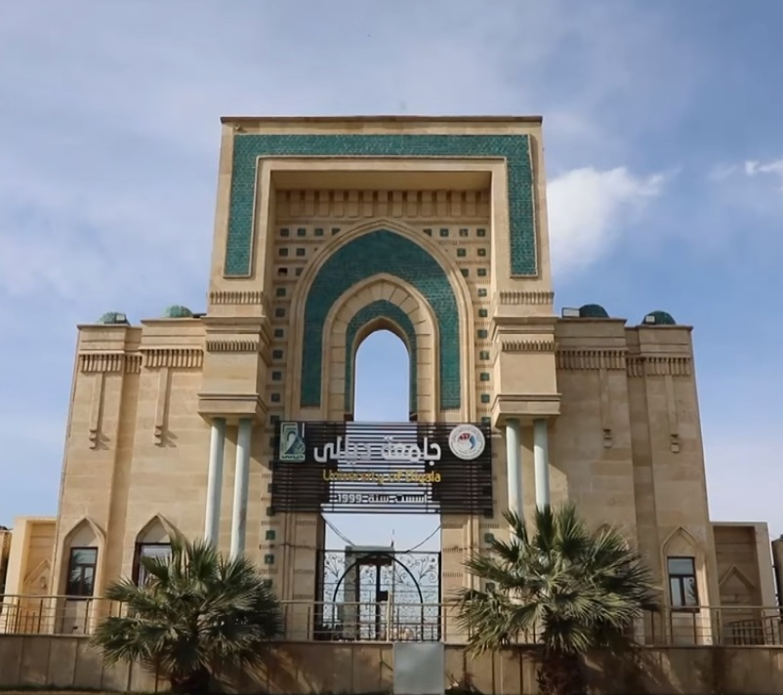

Table of Contents جدول المحتويات

- Mission & Vision Statement | | بيان المهمة والرؤية
- Program Specification | | مواصفات البرنامج
- Program (Objectives) Goals | | أهداف البرنامج
- Program Student learning outcomes | | مخرجات تعلم الطالب
- Academic Staff | | الهيئة التدريسية
- Credits, Grading and GPA | | الاعتمادات والدرجات والمعدل التراكمي
- Modules | | المواد الدراسية
- Contact | | اتصال

Mission & Vision Statement

Vision Statement
An ambitious picture for the future of the academic program to be sophisticated, inspiring, stimulating, realistic and applicable.

Mission Statement

The department pledges to work with a scientific methodology. Institutional work within clear plans to achieve lofty goals in the academic and training fields in accordance with the requirements of quality assurance and academic accreditation, so that its outputs in the subject of the economy are more competitive and ambitious in the labor market through the provision of knowledge, knowledge and skills.

Program Specification

Programmed code: | BSc-CPE | ECTS | 240
Duration: | 4 levels, 8 Semesters | Method of Attendance: | Full Time

The program typically provides students with a solid foundation in economic sciences. This program also provides students with a comprehensive education that qualifies them to occupy leadership positions in various administrative, accounting and financial fields and in preparing economic feasibility studies.

Program Objectives
- Adopting a scientific methodology in the academic and training fields in accordance with the requirements of quality assurance and academic program accreditation in Iraq.
- Striving to make the department’s outputs in administrative sciences more competitive by providing science, knowledge, and skills.
- Transforming teaching and learning processes in administrative sciences into effective practices that contribute to building a developed society.
- Enabling individuals to manage their businesses efficiently and provide useful and productive knowledge to public organizations and society.
- Conducting scientific research that addresses administrative problems faced by public organizations and society.
- Providing consultations and designing advanced systems that address the problems of public organizations and society.
- Providing government organizations with highly scientific, ethical and professional employees.
- Preparing a workforce prepared to work in the government sector and capable of contributing to the implementation of human development plans for the governorate and the country.
- Developing and developing government agencies in the field of local and central government administration, public budgets and government policies through specialized cadres.
- Working to adopt administrative techniques and mechanize administrative work in various types of government departments and agencies in a way that ensures raising the level of efficiency and effectiveness of these agencies.

Student Learning Outcomes
The BSc. program in Economics enables economic, accounting and administrative cadres, who possess the necessary skills to work in various state departments, so students should be able to obtain the following learning outcomes:

Outcome 1
Preparing administrative and economic cadres who possess the necessary skills to work in various state departments
Outcome 2
Developing students’ scientific attitudes to enable them to build themselves and develop their higher studies
Outcome 3
Providing students with leadership skills to manage small and medium enterprises and building expertise in order to develop towards managing any type of project.
Outcome 4
Providing students with knowledge in planning and establishing the economic feasibility of projects
Outcome 5
Cooperating with college departments in the field of exchanging information and experiences.
Encouraging attendance and participation in scientific conferences and seminars,
Outcome 6
Working to prepare and graduate leading scientific and leadership competencies in the field of economic sciences and to develop the balance of knowledge in the field of scientific research in the field of economics to serve the local, regional and international community, as well as training and refining the minds of students scientifically and cognitively, and emphasizing social and cultural values ​​and responding to the requirements of the local market.

Academic Staff
Prof. Mahdi Saleh Dawai / PhD in International Economics
Email: mahdieco@@uodiyala.edu.iq
Mobile no.: 07727765332

Assit.prof.Dr.Nizar Maan Abdul Karim
Email: Dr.NazarM@uodiyala.edu.iq
Mobile no.: 07707101074

Assit. Prof. Dr. Alyaa Hussein Khalaf Al-Zarkroushi
aliaeco@uodiyala.edu.iq
Mobile no 07711838858

Assit.prof.Dr Nadia Mahdi Abdel Qader
Email: nadiaeco@uodiyala.edu.iq
Mobile no 07712019809
Assit. Prof. Dr Omar Mahmood Akawee
Email:omareco@uodiyala.edu.iq
Mobile no 0771102999
Assit. Prof. Dr. Ali Wahib Abdullah
Email:aliwaheebeco@uodiyala.edu.iq
Mobile no 07700807024

Assit. Prof. Dr .diaa Hussein saud
Email: diaaeco@uodiyala.edu.iq
Mobile no 07711064499
Assis Prof.Dr. Mohammed Noori Farhan
Email: mohamedeco@uodiyala.edu.iq
Mobile no 07714446729

Assis Prof.Dr Mohammed Layth Talal
E-mail: mohammedeco@uodiyala.edu.iq
Mobile no 07704335511

Assis Prof..Adnan Taha Karfu
E-mail: Adnantahaq76@gmail.com
Mobile no 07706243848

Assis Prof .Omar Najem Abdullah
E-mail: omareconomics@uodiyala.edu.iq
Mobile no 07706233455

M. Ali Talib Hussein
Email: alieconomics@uodiyala.edu.iq
Mobile no 07711245040
M. Diaa Abdel Razzaq Hassan
EmaiI:diaarazaq@uodiyala.edu.iq
Mobile no 07735950770

Assistant lecturer. Mohammed Saleh Mahdi
Email:lawmoh803@gmail.com
Mobile no 07711338850

Assistant Lecturer Marwa Mahdi Saleh
mryamhademana@uodiyala.edu.iq
Mobile no 07711974180

Assistant lecturer walaa ahmed khalaf
Email: walaaeco@uodiyala.edu.iq
Mobile no 07753624328

Assistant teacher, Anmar Shihab Ahmed
Email: Ali@gmail.com
Mobile no 07724376392

Credits, Grading and GPA
Credits
Diyala University is following the Bologna Process with the European Credit Transfer System (ECTS) credit system. The total degree program number of ECTS is 240, 30 ECTS per semester. 1 ECTS is equivalent to 25 hrs. student workload, including structured and unstructured workload.
Grading
Before the evaluation, the results are divided into two subgroups: pass and fail. Therefore, the results are independent of the students who failed a course. The grading system is defined as follows:

GRADING SCHEME
مخطط الدرجات
Group | Grade | التقدير | Marks (%) | Definition
Success Group  (50 - 100) | A - Excellent | امتياز | 90 - 100 | Outstanding Performance
 | B - Very Good | جيد جدا | 80 - 89 | Above average with some errors
 | C - Good | جيد | 70 - 79 | Sound work with notable errors
 | D - Satisfactory | متوسط | 60 - 69 | Fair but with major shortcomings
 | E - Sufficient | مقبول | 50 - 59 | Work meets minimum criteria
Fail Group  (0 – 49) | FX – Fail | راسب - قيد المعالجة | (45-49) | More work required but credit awarded
 | F – Fail | راسب | (0-44) | Considerable amount of work required
Note:
Number Decimal places above or below 0.5 will be rounded to the higher or lower full mark (for example a mark of 54.5 will be rounded to 55, whereas a mark of 54.4 will be rounded to 54. The University has a policy NOT to condone "near-pass fails" so the only adjustment to marks awarded by the original marker(s) will be the automatic rounding outlined above.

Calculation of the Cumulative Grade Point Average (CGPA)
- The CGPA is calculated by the summation of each module score multiplied by its ECTS, all are divided by the program total ECTS.
CGPA of a 4-year B.Sc. degree:
CGPA = [ (1st ^{m}odule score x ECTS) + (2nd ^{m}odule score x ECTS) + ……] / 240

Curriculum/Modules
Semester 1 | 30 ECTS | 1 ECTS = 25 hrs.
Code | Module | SSWL | USSWL | ECTS | Type | Pre-request
EC1101 | Principles of Microeconomics | 93 | 132 | 9.00 | C
EC1102 | Principles of Management | 63 | 87 | 6.00 | B
EC1103 | Principles of Accounting | 63 | 87 | 6.00 | B
EC1104 | Principles of Economic Mathematics | 48 | 77 | 5.00 | B
UD11 | English language | 33 | 17 | 2.00 | S
UD14 | Democracy and Human Rights | 33 | 17 | 2.00 | S

Semester 2 | 30 ECTS | 1 ECTS = 25 hrs.
Code | Module | SSWL | USSWL | ECTS | Type | Pre-request
EC1201 | Principles of Macroeconomics | 93 | 132 | 9.00 | C
EC1202 | Financial Accounting | 48 | 77 | 5.00 | B
EC1203 | Principles of Statistics | 63 | 87 | 6.00 | B
EC1204 | Economic Readings E | 48 | 77 | 5.00 | B
UD03 | Computer 1 | 63 | 12 | 3.00 | S
UD02 | Arabic Language | 33 | 17 | 2.00 | S

Contact
Program Manager:
Assit. Prof. Dr .diaa Hussein saud
Email: diaaeco@uodiyala.edu.iq
Mobile no 07711064499
Program Coordinator:
M. Ali Talib Hussein
Email: alieconomics@uodiyala.edu.iq
Mobile no 07711245040

